**Environment Variables, Scope Processes, and Organizational Systems**

**Figure 1**

*PMP Inputs*

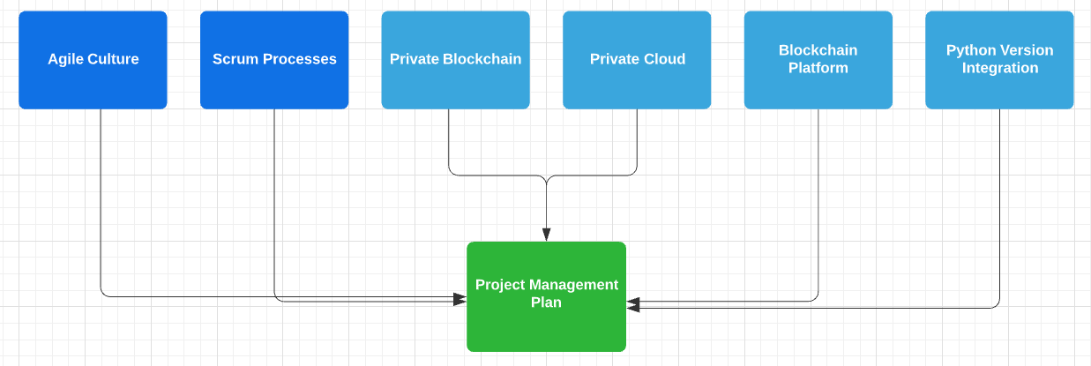

*Note.* Created in <https://lucid.app>.

The Project Management API project planning will need to account for environment variables, scope processes, and organizational systems (see Figure 1). The project will subscribe to an iterative development approach, Agile methodology, specifically using the Scrum framework. Scrum actively limits scope creep and reduces the overall project risk by guaranteeing at least some of the project’s most in demand deliverables (Scrum Alliance, n.d.).

Given that Python 2 is no longer supported as of 2020, any software created or incorporated by third party libraries should use Python 3 (Yegulalp, 2020). Ensuring that any dependencies are Python 3 compatible is crucial.

A blockchain-as-a-service platform should be considered to build and operate a blockchain network (IBM, 2021). The platform would allow engineers to deploy blockchain components to development through production environments. Further, the platform could provide the appropriate security needed for an enterprise blockchain API.

A private blockchain network would allow the client to control who can participate, enact a consensus protocol and manage a shared ledger. The network can be hosted on a private cloud for additional security.

**References**

IBM. (2021, February 14). *Getting started with IBM Blockchain Platform*.

<https://cloud.ibm.com/docs/blockchain?topic=blockchain-get-started-ibp>

Scrum Alliance. (n.d.) *The Agile Manifesto*.

<https://www.scrumalliance.org/resources/agile-manifesto>

Yegulalp, S. (2020, April 22). *Python 2 EOL: How to survive the end of Python 2.*

<https://www.infoworld.com/article/3365221/python-2-end-of-life-how-to-survive-the-end-of-python-2.html>